# Introduction

This project is about the system for recycling product, which facilitates the management of waste product like papers, plastics and glasses. It only concentrates on the waste materials that could be recycled except organic or non-recyclable items. We all know that one ton of recycled paper can save approximately about 20 trees, 4100 Kilowatt hours of electricity; enough energy to power a house for few months. Therefore, it can be said that, this system is an initiative for user or client to contribute some unnecessary things to be of good use by selling and donating things like trash such as papers, glasses, bottles and others for better environment and livelihood. Here, client or supplier can register for an account and they can help by donating or selling their waste product. Which will ultimately help to keep our environment clean and also helps to save tree. With the help of this system user or client can make a good use of their unwanted materials to earn some money. They can also donate glasses, plastics and papers instead of selling it. However, it all depends on the client. In this system all the records of papers, glasses and plastics are kept. So that the recycling company can have a good knowledge about remaining materials which are recycled and the materials which are to be recycled. By doing so both the supplier and recycling company are contributing for the welfare of our environment. It solves the problem of dumping unnecessary waste materials in an unorganized way. Instead of dumping such thing and burning such things one can make a good use of papers, glasses, plastics and others. So, with the help of this system people can sell or donate their recyclable waste materials that are of no use by selecting the suitable dates to book to supply. After selecting suitable dates to sell or donate such items, such items will be collected on particular date and the collector will pay for the recyclable product are which are to be sold by calculating its weight and depending on the weight and type of recyclable items. And the records of such item will be managed accordingly by specifying the category in which they belong to like papers. In papers there will be sub types like magazines, cardboard, notes, book etc. and so on.

This system particularly focuses to close the gap between waste seller and waste collector. So, that waste collector would also be able to utilize the modern technology wisely to make their life easier instead of traveling doors to doors of every individual’s. With the help of this system it will also encourage the business entrepreneur doing business related to recycling.

The client, customer or user of this product will benefit highly. Since this project helps to encourage the business related to recyclable trash and also helps to motivate the common people like us to value the trash or any waste materials that could be re-used or recycled. Which ultimately helps to keep our environment clean and keeps us healthy.

## Aims

* To develop a web based application that facilitates and encourages the waste business by managing the recyclable items that could be re-used.
* To ease the work of recyclable waste collector’s like bottle collector, paper collector.
* To automate the recycled reports

## Objectives

* Developing user friendly web based system using programming language such as PHP and database such as MySQL
* To complete a project in a given time frame to step in a real world project
* To have experience and to learn to solve the problems and errors by identifying bugs and errors.
* Analyze and solves the issue of proper dumping of waste materials.
* To learn to design and develop a dynamic website for a real world project.
* Testing the application to be sure, whether it gives the outcome as expected or not.
* To provide a detailed documentation which could specify every phase of this project

## Main Features

The main features of Recycling System are as follows:

* Registration of client or suppliers.
* Scheduling pickup
* Records of purchased trash
* Records of donated trash
* Show list of recyclable trash
* Login and Logout features
* Signup features

## Development Methods

### Waterfall Model

For this project I prefer to choose Water Fall Model. This model is traditional and straightforward to utilize. It is also known as Liner Sequential Life Cycle Model. This model is difficult to oversee because of the unbending nature of the model – each stage has particular expectations and a survey procedure. In this model stages are handled and finished each one in turn. Stages don't cover. Waterfall shows function admirably for littler activities where prerequisites are very clear. Waterfall consists of six different phases, which are as follows:

* Requirement Analysis:- Requirement Analysis are carried out by different information gathering techniques. For instance, survey, questionnaire, interviews and also through secondary source of data. And then the acquired information is documented in specification document.
* Design:- After the completion of Requirement Analysis. Design is carried out with reference to Requirement Analysis. It consists of two different model i.e. structural and behavioral models. Which helps in implementation phase. After completing the design phase next phase is carried out i.e. Implementation phase is carried out in a chronological order in a waterfall model.
* Implementation:- With the completion of Design phase. Implementation will be carried out with the reference to the design phase and coding will be done likewise following the design phase. Here, system is developed by integrating and coding the system with the help of structural and behavioral model
* Testing:- Testing is and important aspect for developing well and furnished software or system integrating all the features of system. So that the various errors and bugs could be fixed with the help of texting like unit testing and black box testing.
* Deployment:- After following all the development method that are mentioned above. Deployment is done to present the developed system for the real user so that they could utilize its main features.
* Maintenance:-If any errors or breakdowns occur after the completion of all the steps. Maintenance is done to fixed the issues. Not only that system is also upgraded in this phase as per the necessity and demands.

In the Implementation part of waterfall model Design pattern like MVC will be used. By adapting to the MVC framework the coding part is carried out. Here, model handles business logic, view will be responsible for the presentation of state of the mode to the user and finally controller permits user to communicate with the model

# Project Plan

Project Management is a significant assignment for an effective task. It guarantees that a task or a work is finished inside the given time frame in accor to established plan. Inappropriate project administration could prompt extend disappointment.

Despite the fact that I did extra hardwork at the very begin of the recycling project, yet I couldn't fulfill the task in required time with required exertion. This kind of situation arises duet to improper planning and obliviousness prompt this circumstance. For limiting the effect of shameful outcome of administration, I need to put some additional time and extra-work for the project.

## Work Breakdown Structure (WBS and Time Estimate)

A work breakdown structures (WBS) is a graph or a chart that outlines the relationship between the fundamental components, which are decomposed into the smaller activities that are to be performed. The main purpose of WBS is to predict the outcome precisely by organizing and defining the scope of overall project. This is done via hierarchical tree structure where the whole projects are breaks down to more specific and manageable chunks. Which helps to monitor the project by entrusting the responsibilities and managing the project in a controlled manner. Ultimately, it helps to ensure that everything is double-checked and nothing is overlapped. WBS helps us to ensure proper time management for the completion of each and every phase of development methods. Here, the working components are modularized so that the project could be developed in more effective and efficient way.

Given below is the complete Work Breakdown Structure

Figure 1 Work Breakdown Structure

## Milestones

Milestones are the particular point in time, which determines whether or not the project is making any positive development. It ‘s a reference signal post to check the advancement of project that symbolizes the major turning point or decision point within a project. It helps project manager to successfully predict the direction of project, whether it is on schedule or not. It sums up an important value in a project management. Milestone has no duration but it has a fixed dates. It is a unique event that needs more focus. It helps to assure to further advance of project and also to verify on time scheduling of a project for overall development within a fixed date to accurately predict the on time completion of the project.

The table below illustrates the major milestones and their indicated planned deliver dates.

|  |  |
| --- | --- |
| **Milestones** | **Dates** |
| Scoping | Aug 4, 2017 |
| Project Proposal | July 14, 2017 |
| Use Cases | July 25, 2017 |
| Analysis Specification | Aug 1, 2017 |
| Design Specification | Aug 23, 2017 |
| Build Database | Sept 1, 2017 |
| Coding | Sept 15, 2017 |
| Implementation | Sept 15, 2017 |
| Integration Testing | October 9, 2017 |
| Testing | October 9, 2017 |
| User Manual | October 12, 2017 |
| Reporting | October 20, 2017 |

Table: Anticipated Milestones

The above shown tabular representation determines the estimated completion of important phases of system development as milestone of the project. The above mention time period is determined by focusing on the complexity level and maximum period of time that is essential for the completion of such phases of system development

## Schedule

The proper planning for the time estimation of the different activities in this project is done via ProjectLibre. The diagram below illustrates the time management that should be given for the different phases of development. It is done via specifying the main objectives in systematic order to complete the project in sequential order and considering the milestones and the time management of respective development phases that are to be completed on time. With the help of Gantt Chart the time management for the project will be estimated and it will helps us to concentrate and manage our time accordingly. Scheduling also helps to keep a regular track of progress report. It helps project manager to determine the pace of development of different phases. It also helps us to allocate our time with respective to the time needed for the completion of modularized working components.

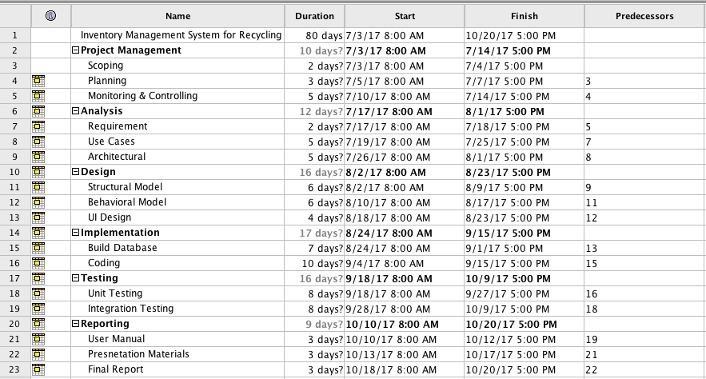

Figure 2 Gantt Chart 1

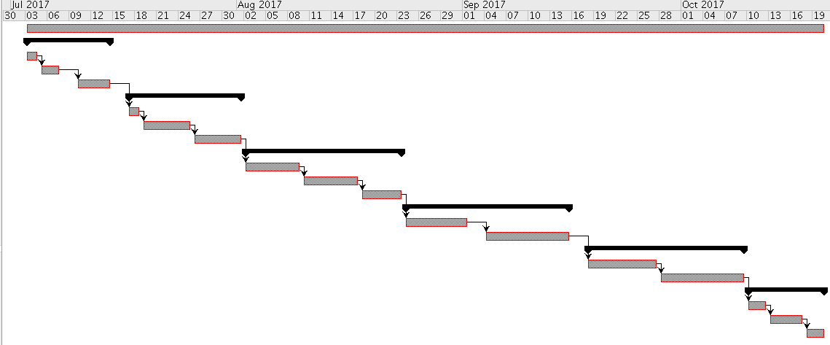

Figure 3 Gantt Chart 2

# Risk Management

While working in a project we may encounter different sorts of risk. It might have a greater negative influence on our project resulting in the delaying in completion of different phases of system development. So, we need to be prepared to face such unlikelihood by managing and identifying the likelihood occurrence of such threats with their negative impacts in our system.

There are four steps for managing and controlling risks on the project

* Identifying Risks
* Assessing the impact of risks
* Alleviating critical risk
* Controlling risks

To predict the likelihood of each impact of identified risks we can use the relation

*Impact=Likelihood x Consequences*

Based on the scale illustrated in the Table 3.1 and Table 3.2 the likelihood and consequences of the risk are determined

|  |  |
| --- | --- |
| **Likelihood** | **Values** |
| Low | 1 |
| Medium | 2 |
| High | 3 |

*Table 3.1: Risk Likelihood Values (Dawson 2005)*

|  |  |
| --- | --- |
| **Consequence** | **Value** |
| Very Low | 1 |
| Low | 2 |
| Medium | 3 |
| High | 4 |
| Very High | 5 |

*Table 3.2: Risk Consequence Value (Dawson 2005)*

The tabular representation illustrated below represents the risk and their possible consequence value with regards to the vale assigned from the above table. The appropriate measures to mitigate the risk are present on the end column.

|  |  |  |  |  |
| --- | --- | --- | --- | --- |
| **Risk** | **Likelihood** | **Consequence** | **Impact** | **Action** |
| Scarce of required resources | 1 | 4 | 4 | Research the resource required and be well prepared to begin with. |
| Flaw in estimation and scheduling | 2 | 5 | 10 | Should concentrates more on planning of the project analysis should be done well |
| System Failure | 1 | 5 | 5 | Timely maintenance and backup should be done on regular basis |
| Illness | 3 | 2 | 6 | Time lost by the sick leave should be cover by working extra hours. |
| Power Cut | 1 | 4 | 4 | Extra back up power should used |
| Disaster | 1 | 4 | 4 | External backup and cloud-based backup should be done so that the system will not be affected. |
| Human Error | 4 | 3 | 12 | Double check and correction in the development phase should be done carefully |

# Configuration Management

Configuration Management is the process that tends to maintain integrity over time by preserving the systematic changes so that it could be accessed when necessary. It ensures that amendment in any segment will not have any effect on the other stages of project. It facilitates easy backup of the project artifacts. It maintains the consistency and discipline form implementing any amendments in the artifacts.

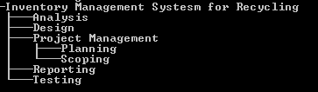

Figure 4 Tree structure

# Conclusion

To conclude, a proposal for recycling is completed. Here, various plans and techniques will be used as per the necessity for the completion of project. The main aims, objectives and features are specified. And the necessary preparation for completing the project is planned properly for easy management system. Development method is decomposed into smaller component so that it could be completed as planned in a systemic manner. In-order to manage and estimate the time properly. A Gantt chart is created where approximate estimation for the completion of project is created which were decomposed into smaller components. Each and every phase have a proper well-estimated duration for completion of the task. Hence, the system for recycling will be developed with reference to the planning and project management done as mention above in the proposal.

# References

Waterfall Model

<http://istqbexamcertification.com/what-is-waterfall-model-advantages-disadvantages-and-when-to-use-it>

WBS

<https://www.projectsmart.co.uk/work-breakdown-structure-purpose-process-pitfalls.php>

Milestone

<https://www.wrike.com/project-management-guide/faq/what-is-a-milestone-in-project-management/>

Risk Management

<http://searchcompliance.techtarget.com/definition/risk-management>